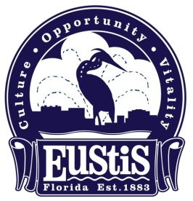





**NEWS RELEASE** Contact Kay Yaccarino

**November 27, 2023** (352) 483-5432

**Celebrate Christmas at Eustis First Friday**

EUSTIS – Enjoy falling snow, a visit with Santa Claus, live music, food, shopping and more at First Friday in downtown Eustis, December 1 from 6 to 9 p.m.

Retro Ramblers is performing throughout the evening on the downtown stage, with the Eustis High School Band performing at 6 p.m. at Magnolia and Grove Streets, and Lifepoint Church appearing at 7:30 p.m. at the Ferran Park Bandshell.

Children can visit with Santa Claus during the event behind the bandshell to share their Christmas wishes and parents are welcome to take photos. Snow will be falling every half hour, beginning at 6 p.m., for 10 minutes of magic in Ferran Park.

The holiday festivities continue every Friday from December 1 to December 29 from 6 to 9 p.m. with Snowflakes by the Lake at Ferran Park, featuring Santa Claus on the bandshell until Dec. 22. The 50-foot Christmas tree will be glowing with lights and music every night throughout the month.

For more information, visit the City of Eustis website at Eustis.org and the city’s Facebook pages, City of Eustis 2 and City of Eustis Events.